**TITLE**

**Author1a, Author2b**

*aAffiliation*

*bAffiliation*

*email for presenting author*

**ABSTRACT**

The abstract should be written in The Times New Roman 12pt font, up to 500 words, and the line spacing of the abstract should be 1,5. Page margins (left, right, bottom and top) should be 2.5 cm. The title should be written using 12pt, bold, сenter. Literature references in the text should be given [1], [1,2], or [1-3]. The appropriate format for the reference list is shown below.

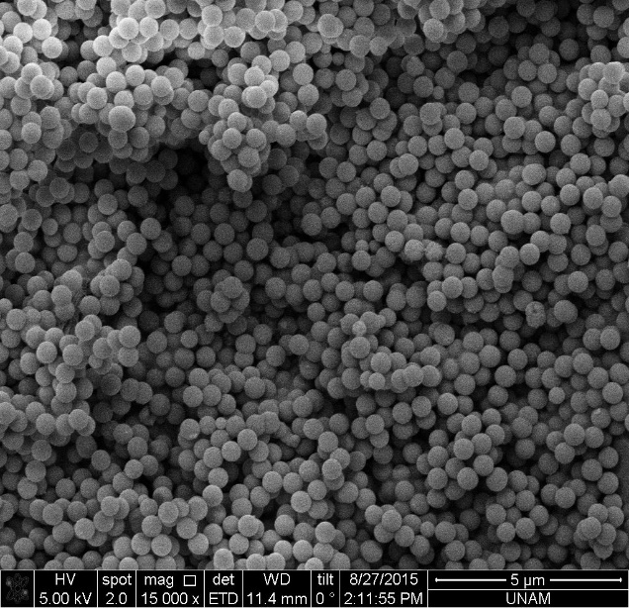

**Figure 1.** (with description)

**Keywords:** 5 words separated by commas in alphabetical order.

**REFERENCES**

References should be numbered as [1], [2], [3]…. Respectively.

References should be written in The Times New Roman 10pt font with one line spacing.

**Journal article**

[1] J. van der Geer, J.A.J. Hanraads, R.A. Lupton, The art of writing a scientific article, J. Sci. Commun. 163 (2010) 51–59. <https://doi.org/10.1016/j.Sc.2010.00372>.

**Journal article with DOI**

[2] Van der Geer, J., Hanraads, J.A.J., Lupton, R.A., 2018. The art of writing a scientific article. Heliyon. 19, e00205. https://doi.org/10.1016/j.heliyon.2018.e00205.

**Book**

[3] W. Strunk Jr., E.B. White, The Elements of Style, fourth ed., Longman, New York, 2000.

**Book chapter**

[4] G.R. Mettam, L.B. Adams, How to prepare an electronic version of your article, in: B.S. Jones, R.Z. Smith (Eds.), Introduction to the Electronic Age, E-Publishing Inc., New York, 2009, pp. 281–304.

**Thesis and research report**

[5] B. Baki, Kurumsal Kaynak Planlaması Yazılım Seçimi, Karadeniz Teknik Üniversitesi Sosyal Bilimler Enstitüsü İşletme Bölümü, Doktora Tezi, Trabzon, 2000.

**Website**

[6] Cancer Research UK, Cancer statistics reports for the UK. <http://www.cancerresearchuk.org/> aboutcancer/statistics/cancerstatsreport/, 2003 (accessed 13 March 2003).